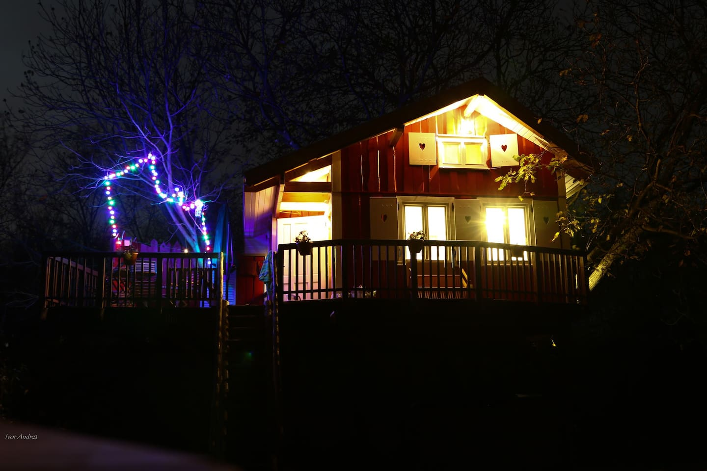

<https://www.airbnb.ca/rooms/18502468?source_impression_id=p3_1581281125_QyLff6GnvUCoW6Vr>

**WalnutTREEHOUSE**

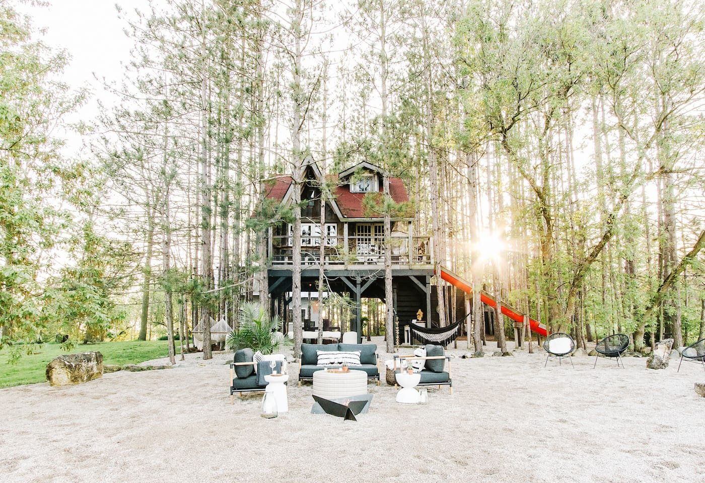

<https://www.airbnb.ca/rooms/3153111?source_impression_id=p3_1581281503_1jtPXykOhBUNH22O>

**Treehouse + Cabin Retreat**

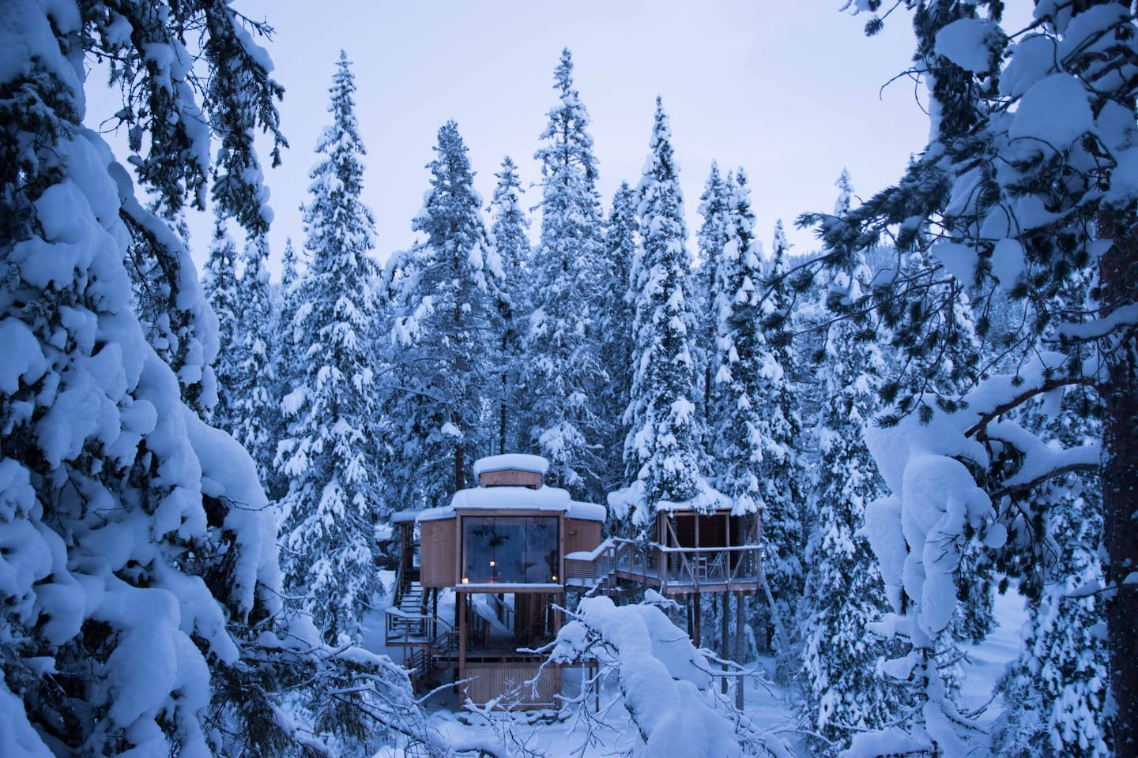

<https://www.airbnb.ca/rooms/14032398?source_impression_id=p3_1581281673_D%2FBeiQarMw3xfRHH>

**Auge - River Eye - Treehouse**

Experience being in the trees, looking out into the surrounding nature from a warm and well design treehouse

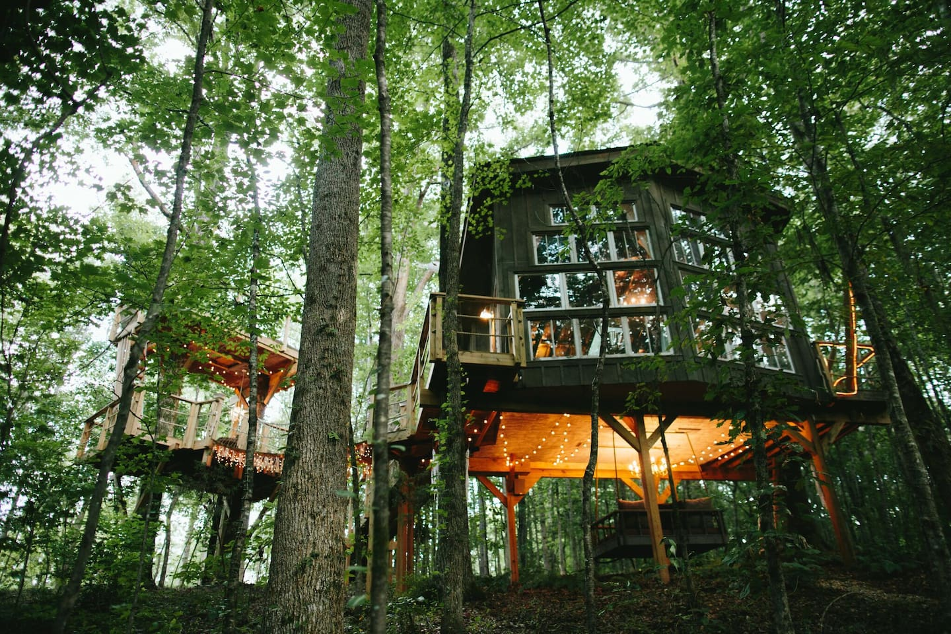

<https://www.airbnb.ca/rooms/8319626?source_impression_id=p3_1581281877_NrUdkxoFB3PD%2FtIc>

**THE MAJESTIC TREEHOUSE romantic, luxury retreat**

LIVE LIKE KINGS & PLAY LIKE KIDS in this extraordinary, award-winning treehouse hidden in 40 acres of paradise! Cozy, whimsical & glamorous; 2 connecting treehouse decks transport you to utopia! Fireplace & AC, indoor plumbing, outdoor shower, record player, antiques!! Rest, reconnect & have an Unforgettable Experience!

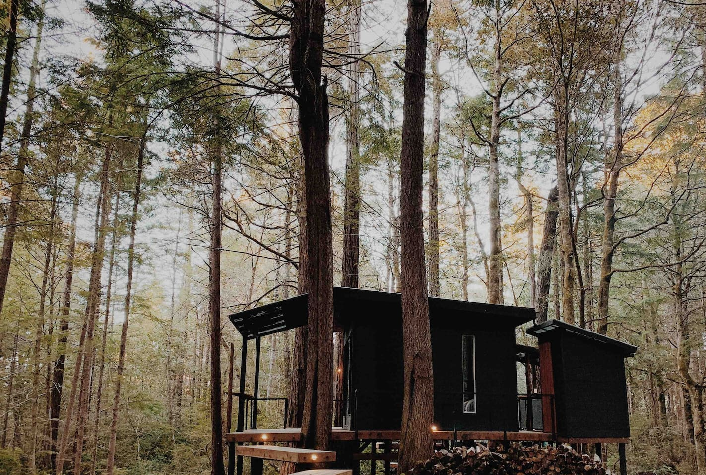

<https://www.airbnb.ca/rooms/11552876?source_impression_id=p3_1581282006_nmqwsZZmDnaSRGXZ>

**Forest Camping Hut**

Enjoy a private redwood forest camping hut. Rustic ... yet designed with comfort in mind. A getaway nestled among the forest a few miles inland from the Pacific Ocean.

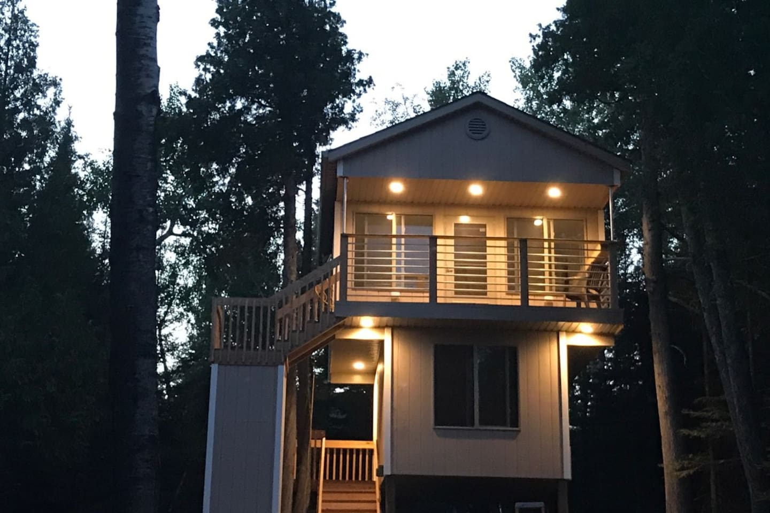

<https://www.airbnb.ca/rooms/33114382?source_impression_id=p3_1581282196_RAT1ODMgkf4OLNRL>

**The ReTreet House**

Be a part of nature and stay at a house among the trees. A unique place to unwind or recharge, or a home base to explore the many activities of Lake Superior's north shore.

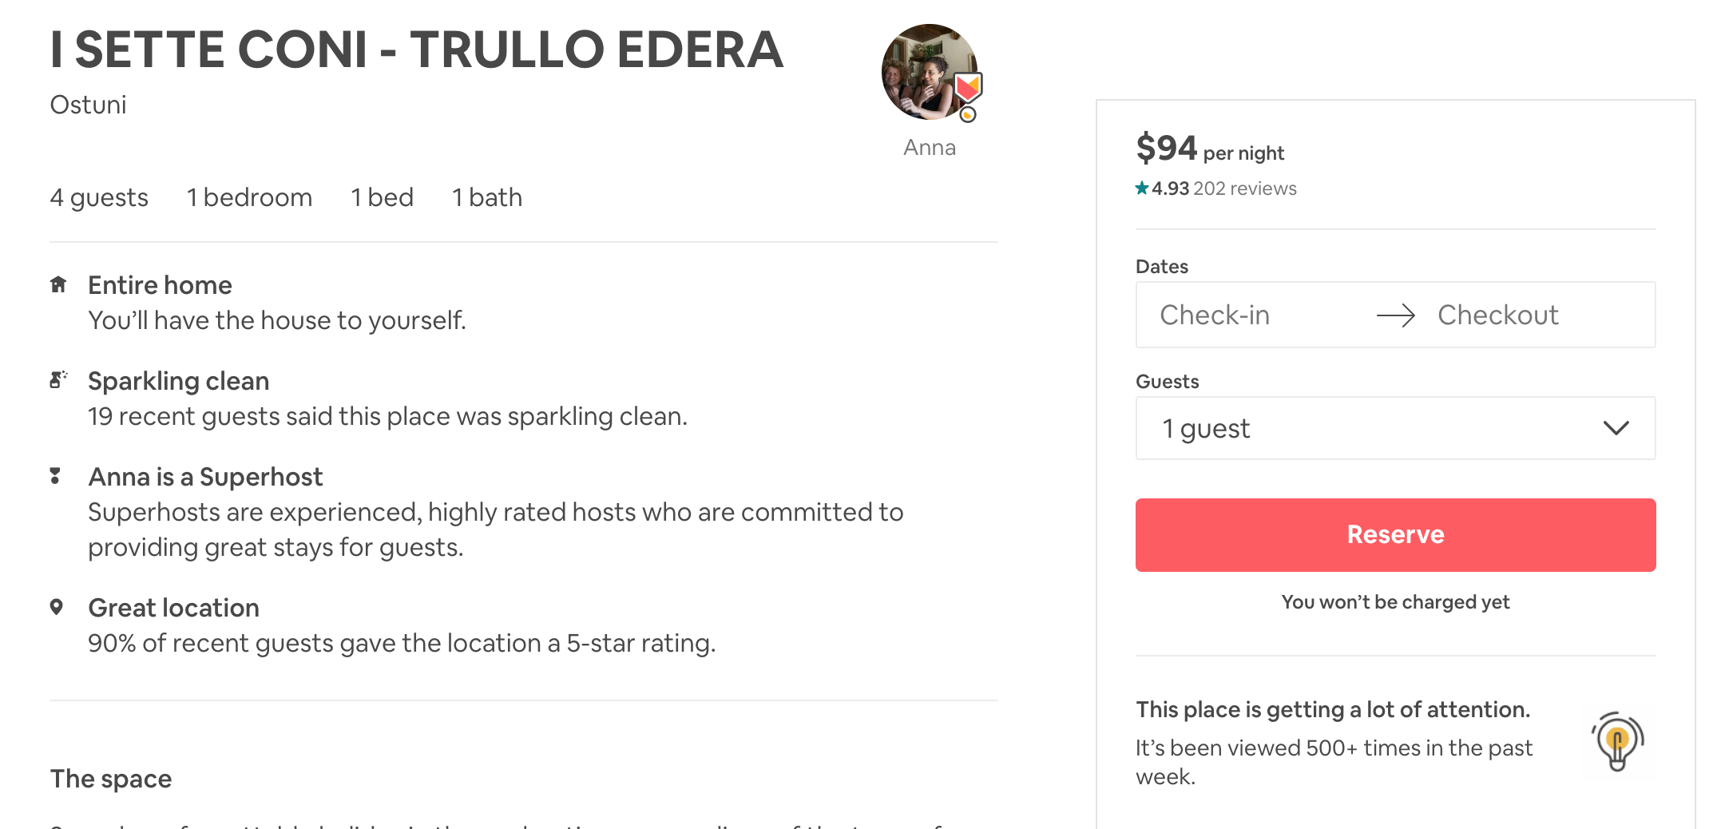

<https://www.airbnb.ca/rooms/432044?source_impression_id=p3_1579817807_fGS9hJxo%2B1uwwWm0>

<https://www.airbnb.ca/rooms/530250?source_impression_id=p3_1579818064_1RFPYEvaYSkZ%2FTc9>

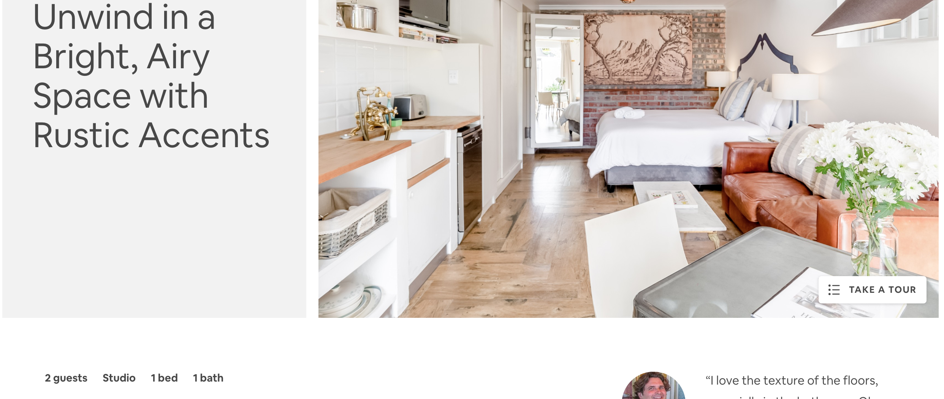

<https://www.airbnb.ca/rooms/plus/4646142?source_impression_id=p3_1579818216_SBAGeb3hgLDl7xN0>

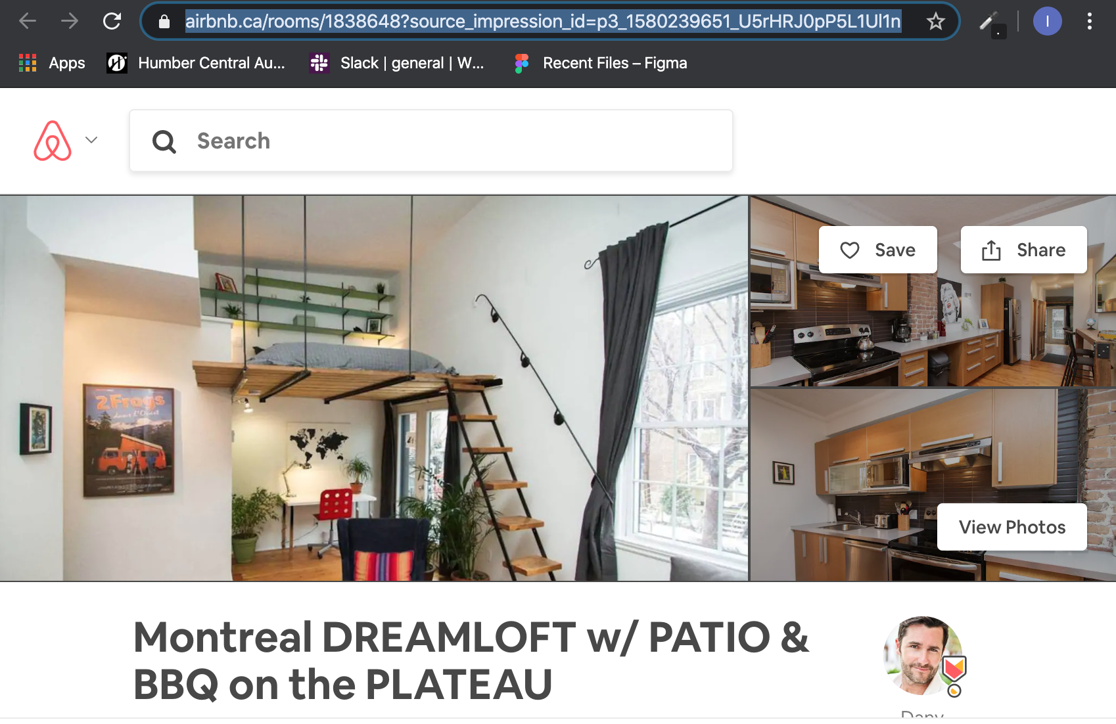

<https://www.airbnb.ca/rooms/1838648?source_impression_id=p3_1580239651_U5rHRJ0pP5L1Ul1n>

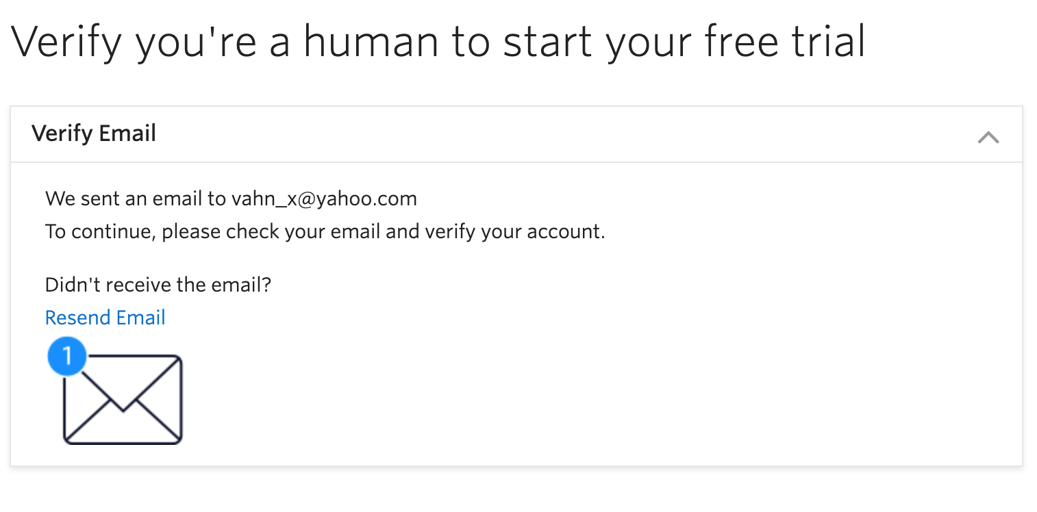

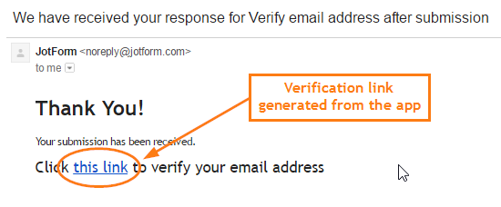

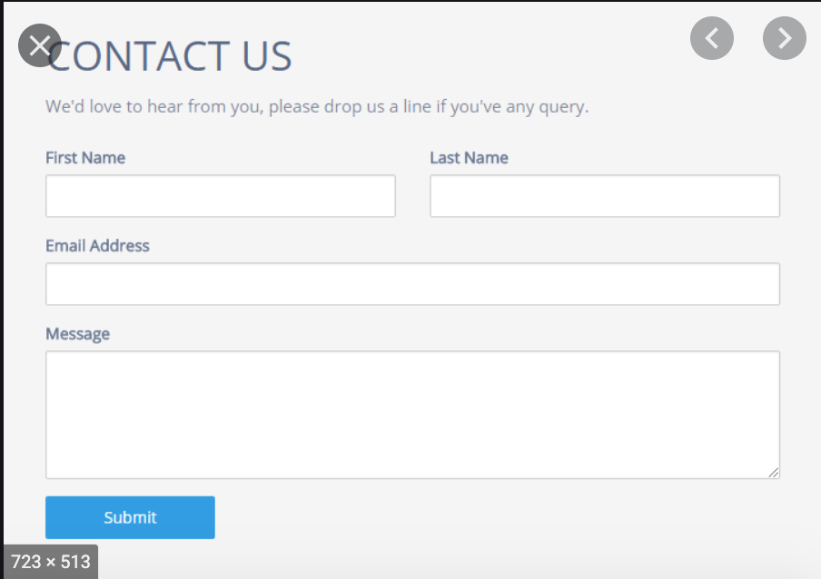

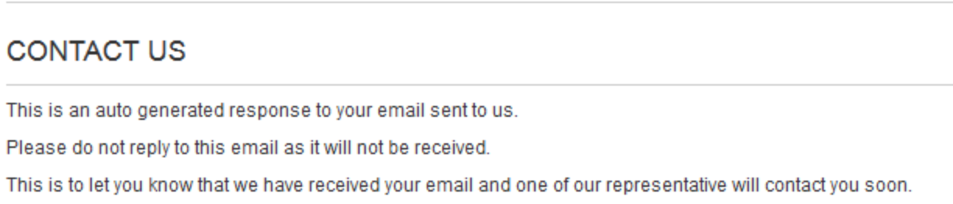

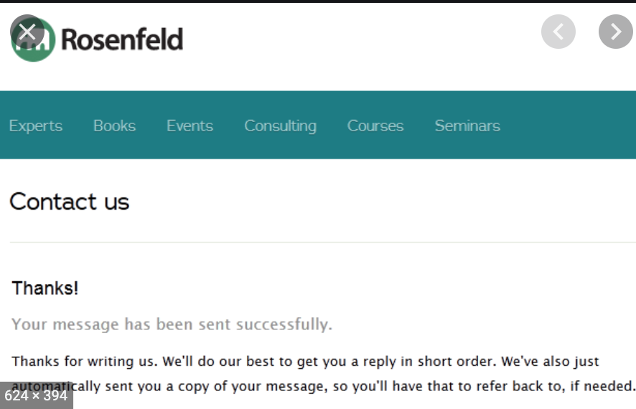

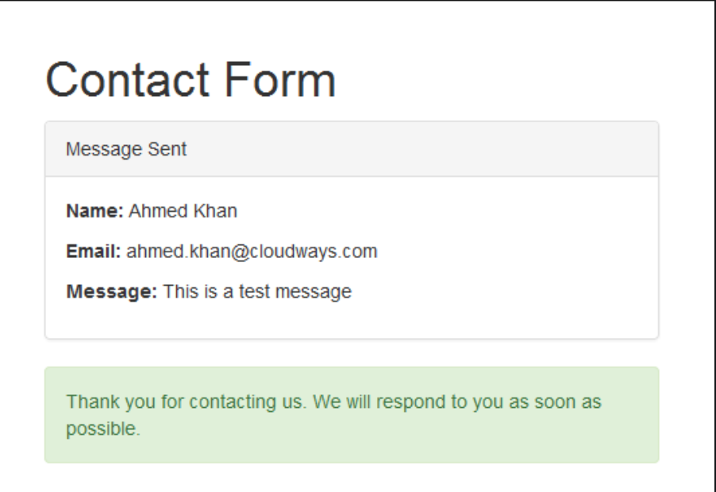

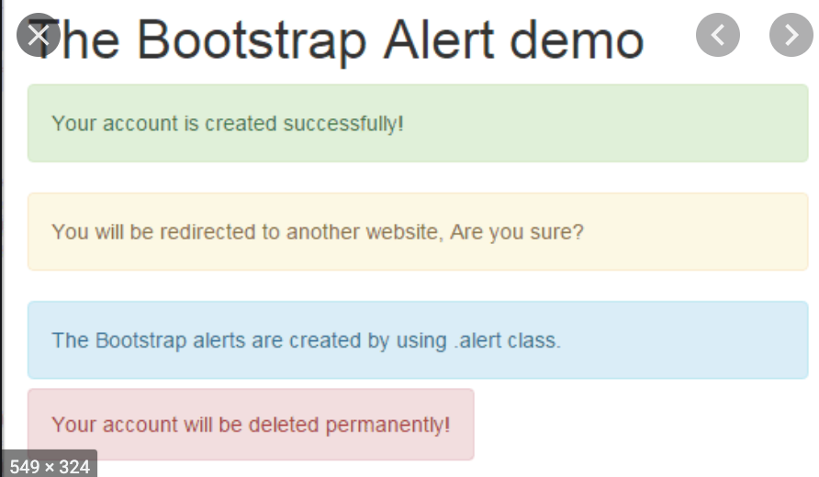



.slider{

/* background-color: blue; */

}

.slider-holder

{

width: 100%;

height: 100%;

/* background-color: yellow; */

margin-left: auto;

margin-right: auto;

margin-top: 0px;

text-align: center;

overflow: hidden;

}

.image-holder

{

width: 80rem;

height: 10rem;

/* background-color: red; */

/* height: 400px; */

clear: both;

position: relative;

-webkit-transition: left 2s;

-moz-transition: left 2s;

-o-transition: left 2s;

transition: left 2s;

background-image: url(/img/sliders/slider04.jpg);

}

.slider-image

{

float: left;

margin: 0px;

padding: 0px;

position: relative;

}

#slider-image-1:target ~ .image-holder

{

left: 0px;

}

#slider-image-2:target ~ .image-holder

{

left: -800px;

}

#slider-image-3:target ~ .image-holder

{

left: -1600px;

}

.button-holder

{

position: relative;

top: -20px;

}

.slider-change

{

display: inline-block;

height: 10px;

width: 10px;

border-radius: 5px;

background-color: brown;

}

<div class="slider-holder">

<span id="slider-image-1"></span>

<div class="image-holder">

<p class="slider-image"></p>

</div>

<div class="button-holder">

<a href="#slider-image-1" class="slider-change"></a>

</div>

</div>